**Exp.No: 1**

**Downloading and installing Hadoop, Understanding different Hadoop modes, Startup scripts, Configuration files.**

**AIM:**

To Download and install Hadoop, Understanding different Hadoop modes, Startup scripts, Configuration files.

**Procedure:**

**Step 1 : Install Java Development Kit**

The default Ubuntu repositories contain Java 8 and Java 11 both. But, Install Java 8 because hive only works on this version. Use the following command to install it.

# $sudo apt update&&sudo apt install openjdk-8-jdk

**Step 2 : Verify the Java version**

Once installed, verify the installed version of Java with the following command: **$ java -version Output:**



**Step 3: Install SSH**

SSH (Secure Shell) installation is vital for Hadoop as it enables secure communication between nodes in the Hadoop cluster. This ensures data integrity, confidentiality, and allows for efficient distributed processing of data across the cluster. **$sudo apt install ssh**

**Step 4 : Create the hadoop user :**

All the Hadoop components will run as the user that you create for Apache Hadoop, and the user will also be used for logging in to Hadoop’s web interface. Run the command to create user and set password:

**$ sudo adduser hadoop**

**Step 5 : Switch user**

Switch to the newly created hadoop user:

**$ su - hadoop**

**Step 6 : Configure SSH**

Now configure password-less SSH access for the newly created hadoop user, so didn’t enter the key to save file and passphrase. Generate an SSH keypair (generate Public and Private Key Pairs)first

**$ ssh-keygen -t rsa**

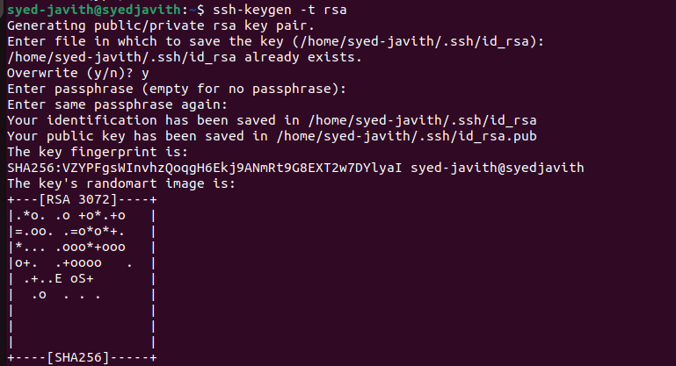

**Step 7 : Set permissions :**

Next, append the generated public keys from id_rsa.pub to authorized_keys and set proper permission:

**$ cat ~/.ssh/id_rsa.pub >> ~/.ssh/authorized_keys**

**$ chmod 640 ~/.ssh/authorized_keys**

**Step 8 : SSH to the localhost**

Next, verify the password less SSH authentication with the following command:

**$ ssh localhost**

You will be asked to authenticate hosts by adding RSA keys to known hosts. Type yes and hit Enter to authenticate the localhost:

**Step 9 : Switch user**

Again switch to hadoop. So, First, change the user to hadoop with the following command: **$ su–hadoop**

**Step 10 : Install hadoop**

Next, download the latest version of Hadoop using the wget command:

**$ wget**[**https://downloads.apache.org/hadoop/common/hadoop-3.3.6/hadoop-3.3.6.tar.gz**](https://downloads.apache.org/hadoop/common/hadoop-3.3.6/hadoop-3.3.6.tar.gz) Once downloaded, extract the downloaded file:

**$ tar -xvzf hadoop-3.3.6.tar.gz**

Next, rename the extracted directory to hadoop:

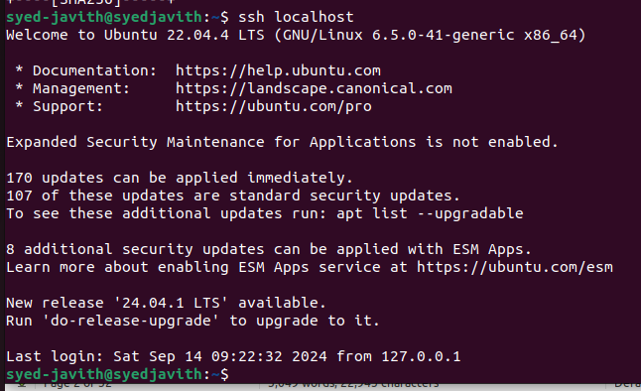

**$ mv hadoop-3.3.6 hadoop**

Next, you will need to configure Hadoop and Java Environment Variables on your system. Open the ~/.bashrc file in your favorite text editor. Use nano editior , to pasting the code we use ctrl+shift+v for saving the file ctrl+x and ctrl+y ,then hit enter:

Next, you will need to configure Hadoop and Java Environment Variables on your system.

Open the ~/.bashrc file in your favorite text editor:

**$ nano ~/.bashrc**

Append the below lines to file.

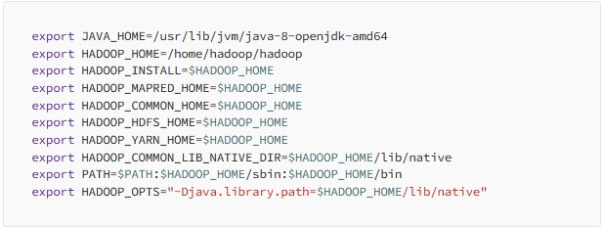

Save and close the file. Then, activate the environment variables with the following command:

**s$ source ~/.bashrc**

Next, open the Hadoop environment variable file: **$ nano $HADOOP_HOME/etc/hadoop/hadoop-env.sh**

Search for the “export JAVA_HOME” and configure it.

JAVA_HOME=/usr/lib/jvm/java-8-openjdk-amd64

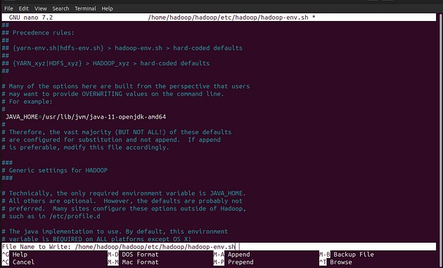

Save and close the file when you are finished.

**Step 11 : Configuring Hadoop :**

First, you will need to create the namenode and datanode directories inside the Hadoop user home directory. Run the following command to create both directories:

**$ cd hadoop**/

**$mkdir -p ~/hadoopdata/hdfs/{namenode,datanode}**

• Next, edit the core-site.xml file and update with your system hostname:

# $nano $HADOOP_HOME/etc/hadoop/core-site.xml

Change the following name as per your system hostname:

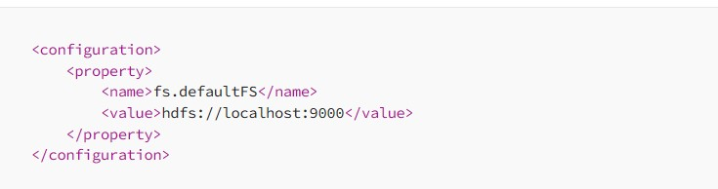

Save and close the file.

Then, edit the hdfs-site.xml file:

# $nano $HADOOP_HOME/etc/hadoop/hdfs-site.xml

* Change the NameNode and DataNode directory paths as shown below:

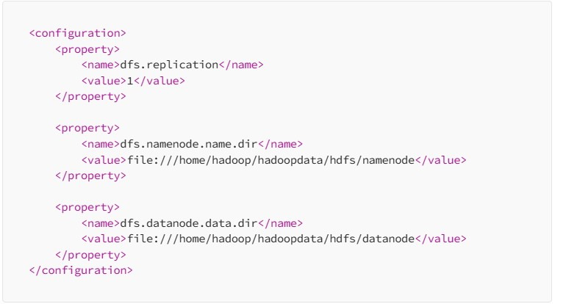

* Then, edit the mapred-site.xml file:

# $nano $HADOOP_HOME/etc/hadoop/mapred-site.xml

•

Make the following changes:

•

Then, edit the

yarn

-

site.xml file:

**$**

**nano**

**$HADOOP_HOME**

**/etc/hadoop/yarn**

**-**

**site.xm**

**l**

•

Make the following changes:

Save the file and close it .

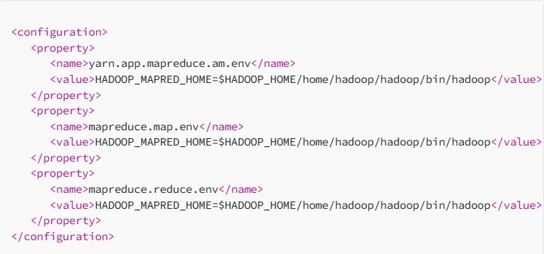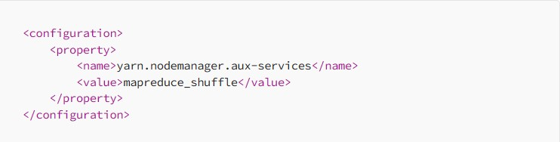

**Step 12 – Start Hadoop Cluster**

Before starting the Hadoop cluster. You will need to format the Namenode as a hadoop user.

Run the following command to format the Hadoop Namenode:

$hdfs namenode –format

Once the namenode directory is successfully formatted with hdfs file system, you will see the message “Storage directory /home/hadoop/hadoopdata/hdfs/namenode has been successfully formatted “

Then start the Hadoop cluster with the following command.

**$ start-all.sh**

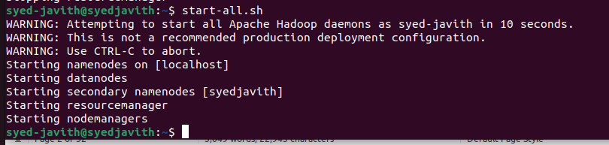

You can now check the status of all Hadoop services using the jps command:

**$ jps**

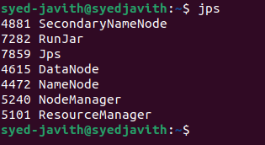

**Step 13 – Access Hadoop Namenode and Resource Manager**

• First we need to know our ipaddress, In Ubuntu we need to install net-tools to run ipconfig command,

If you installing net-tools for the first time switch to default user:

# $sudo apt install net-tools

* Then run ifconfig command to know our ip address: **ifconfig**

Here my ip address is 192.168.1.6.

* To access the Namenode, open your web browser and visit the URL http://your-serverip:9870.
* You should see the following screen:

[**http://192.168.1.6:9870**](http://hadoop.tecadmin.net:9870/)

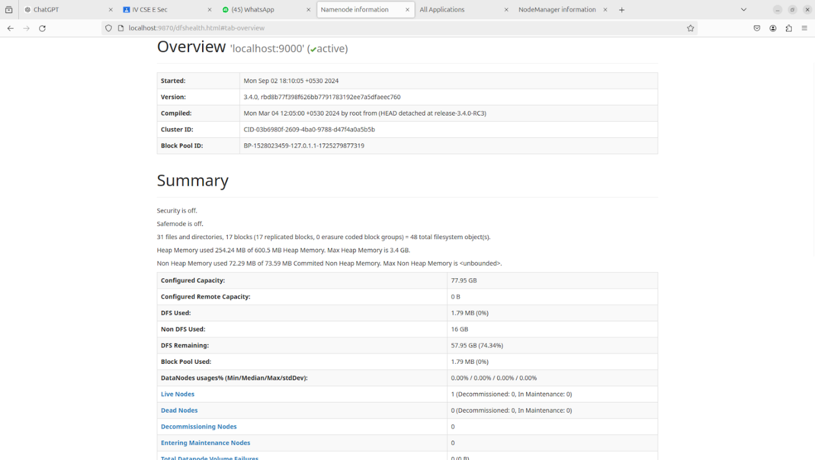

To access Resource Manage, open your web browser and visit the URL http://your-serverip:8088. You should see the following screen: [http://192.168.16:8088](http://hadoop.tecadmin.net:8088/)

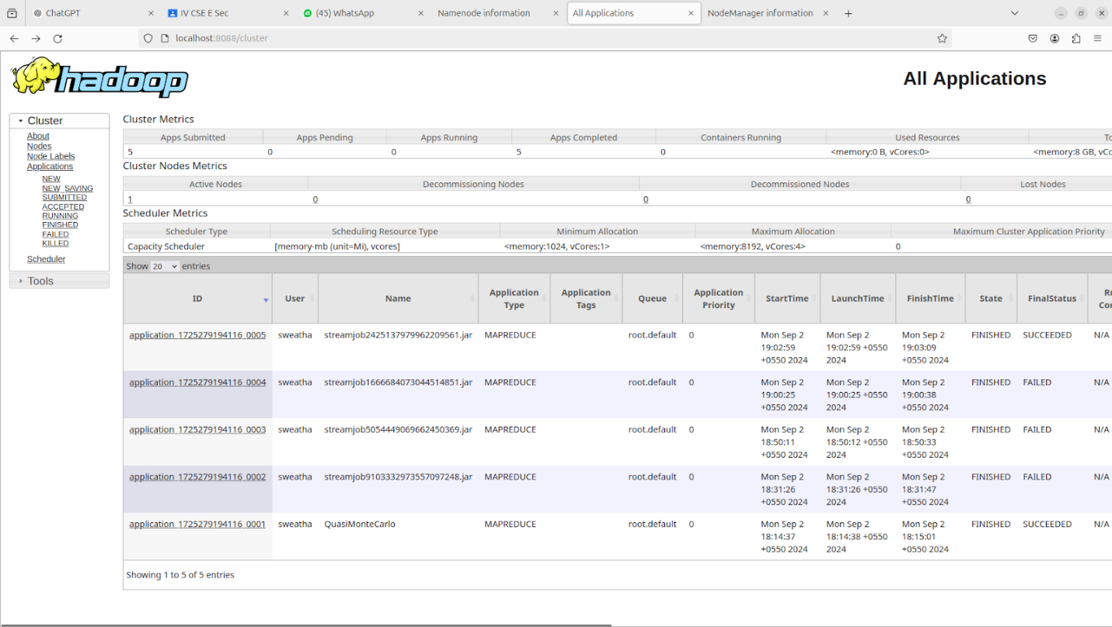

**Step 14 – Verify the Hadoop Cluster**

At this point, the Hadoop cluster is installed and configured. Next, we will create some directories in the HDFS filesystem to test the Hadoop.

Let’s create some directories in the HDFS filesystem using the following command:

**$ hdfsdfs**

**-**

**mkdir /test1**

**$ hdfsdfs**

**-**

**mkdir /logs**

Next, run the following command to list the above directory:



Also, put some files to hadoop file system. For the example, putting log files from host machine to hadoop file system.

|  |  |  |
| --- | --- | --- |
| **$ hdfs dfs -put /var/log/* /logs/** | | |
|  |  |  |

You can also verify the above files and directory in the Hadoop Namenode web interface.

Go to the web interface, click on the Utilities => Browse the file system. You should see your directories which you have created earlier in the following screen:

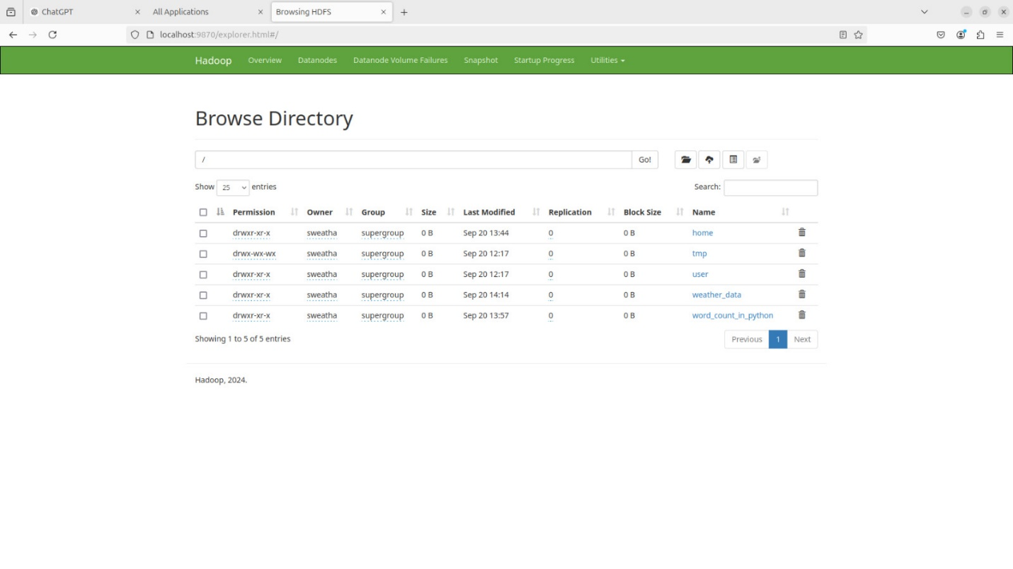

**Step 15 –** Stop Hadoop Cluster

To stop the Hadoop all services, run the following command:

**$ stop-all.sh**

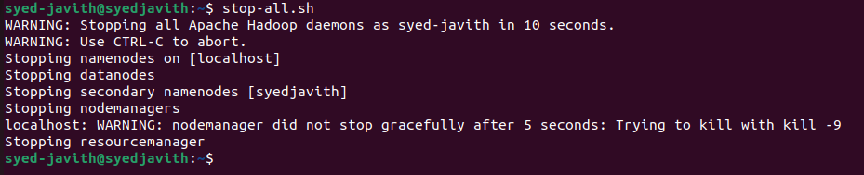

**Result:**

The step-by-step installation and configuration of Hadoop on Ubutu linux system have been successfully completed.

**Exp.No: 2**

**Run a basic Word Count Map Reduce program to understand Map Reduce Paradigm**

**AIM:**

To run a basic Word Count MapReduce program.

**Procedure:**

**Step 1: Create Data File:**

Create a file named "word_count_data.txt" and populate it with text data that you wish to analyse.

Login with your hadoop user.

**nano word_count.txt**

Output: Type the below content in word_count.txt



**Step 2: Mapper Logic - mapper.py:**

Create a file named "mapper.py" to implement the logic for the mapper. The mapper will read input data from STDIN, split lines into words, and output each word with its count.

nano mapper.py

# Copy and paste the mapper.py code

#!/usr/bin/env python3

# import sys because we need to read and write data to STDIN and STDOUT

#!/usr/bin/python3

import sys

for line in sys.stdin:

line = line.strip() # remove leading and trailing whitespace

words = line.split() # split the line into words

for word in words:

print( '%s\t%s' % (word, 1))

.

**Step 3: Reducer Logic - reducer.py:**

Create a file named "reducer.py" to implement the logic for the reducer. The reducer will aggregate the occurrences of each word and generate the final output.

nano reducer.py

# Copy and paste the reducer.py code

**reducer.py**

#!/usr/bin/python3 from operator import itemgetter import sys current_word = None current_count = 0 word = None for line in sys.stdin: line = line.strip() word, count = line.split('\t', 1) try:

count = int(count) except ValueError: continue if current_word == word: current_count += count else:

if current_word:

print( '%s\t%s' % (current_word, current_count)) current_count = count current_word = word if current_word == word: print( '%s\t%s' % (current_word, current_count))

**Step 4: Prepare Hadoop Environment:**

Start the Hadoop daemons and create a directory in HDFS to store your data.

## start-all.sh hdfsdfs -mkdir /word_count_in_python hdfsdfs -copyFromLocal /path/to/word_count.txt/word_count_in_python

**Step 6: Make Python Files Executable:**

Give executable permissions to your mapper.py and reducer.py files.

## chmod 777 mapper.py reducer.py

**Step 7: Run Word Count using Hadoop Streaming:**

Download the latest hadoop-streaming jar file and place it in a location you can easily access.

Then run the Word Count program using Hadoop Streaming.

hadoop jar /path/to/hadoop-streaming-3.3.6.jar \ -input /word_count_in_python/word_count_data.txt \

-output /word_count_in_python/new_output \

-mapper /path/to/mapper.py \

-reducer /path/to/reducer.py

**Step 8: Check Output:**

Check the output of the Word Count program in the specified HDFS output directory.

hdfs dfs -cat /word_count_in_python/new_output/part-00000

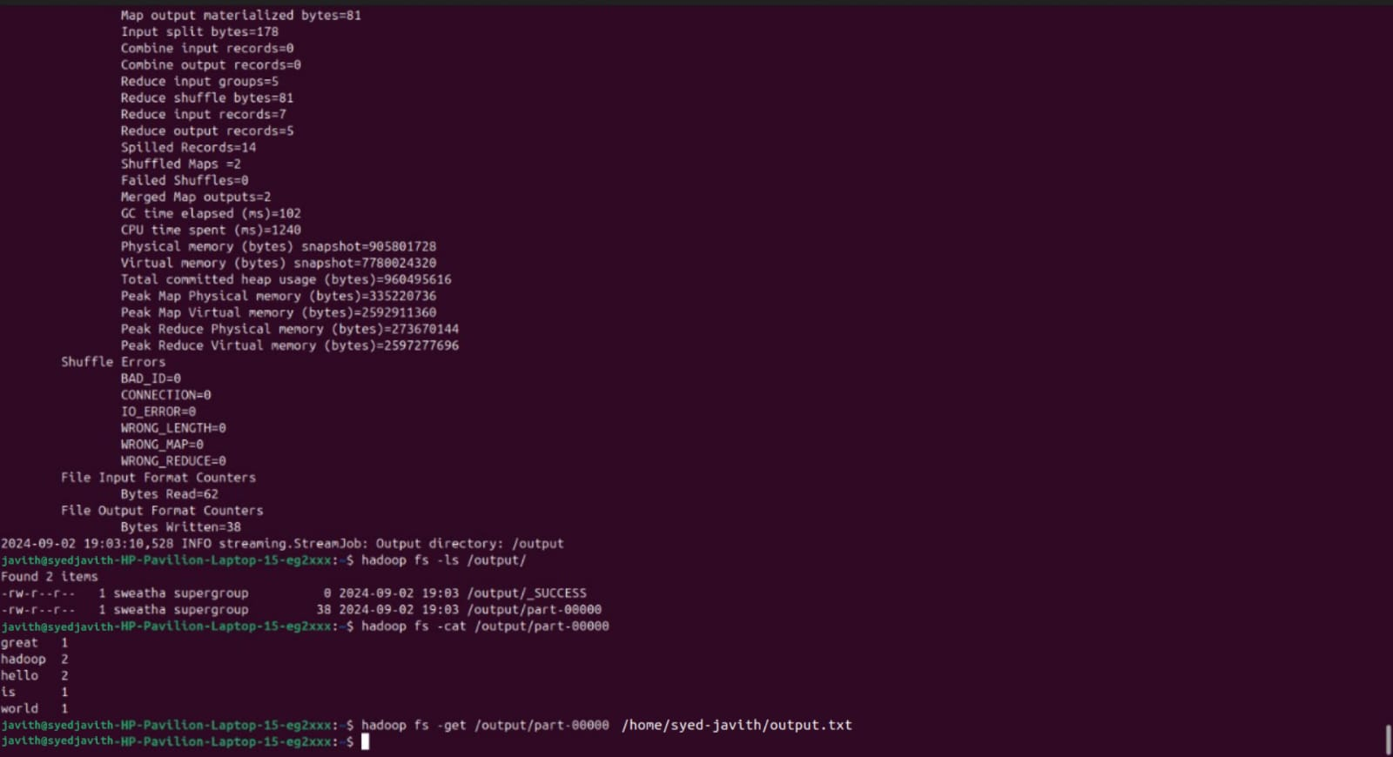

**Result:**

Thus, the program for basic Word Count Map Reduce has been executed successfully.

**Exp.No.: 3 Map Reduce program to process a weather dataset**

**AIM:**

To implement MapReduce program to process a weather dataset.

**Procedure:**

**Step 1: Create Data File:**

Create a file named "word_count_data.txt" and populate it with text data that you wish to analyse.

Login with your hadoop user.

**Download the dataset (weather data)**

Output:

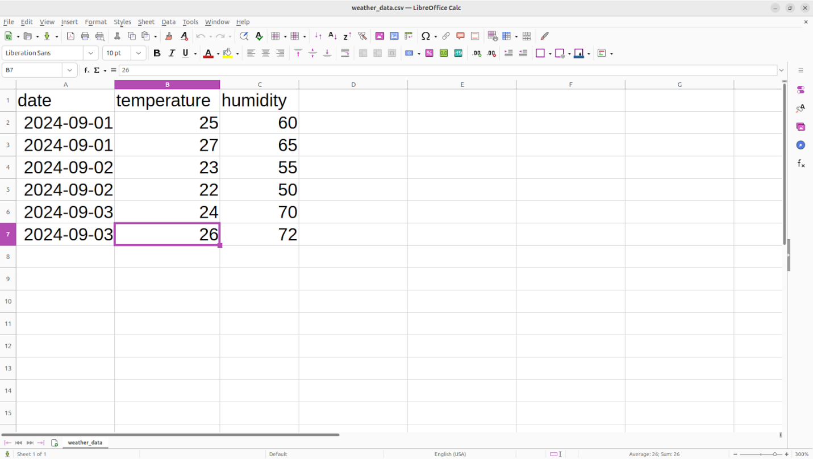

**Step 2: Mapper Logic - mapper.py:**

Create a file named "mapper.py" to implement the logic for the mapper. The mapper will read input data from STDIN, split lines into words, and output each word with its count.

nano mapper.py

# Copy and paste the mapper.py code

#!/usr/bin/env python

import sys

# input comes from STDIN (standard input)

# the mapper will get daily max temperature and group it by month. so output will be

(

month,dailymax_temperature

)

for line in sys.stdin:

# remove leading and trailing whitespace

line = line.strip() # split the line into words words = line.split()

#See the README hosted on the weather website which help us understand how each position represents a column month = line[10:12] daily_max = line[38:45] daily_max = daily_max.strip()

# increase counters for word in words:

# write the results to STDOUT (standard output);

# what we output here will be go through the shuffle proess and then

# be the input for the Reduce step, i.e. the input for reducer.py

#

# tab-delimited; month and daily max temperature as output print ('%s\t%s' % (month ,daily_max))

.

**Step 3: Reducer Logic - reducer.py:**

Create a file named "reducer.py" to implement the logic for the reducer. The reducer will aggregate the occurrences of each word and generate the final output.

nano reducer.py

# Copy and paste the reducer.py code

**reducer.py**

#!/usr/bin/env python

from operator import itemgetter import sys

#reducer will get the input from stdid which will be a collection of key, value(Key=month , value= daily max temperature)

#reducer logic: will get all the daily max temperature for a month and find max temperature for the month

#shuffle will ensure that key are sorted(month)

current_month = None current_max = 0 month = None

# input comes from STDIN for line in sys.stdin:

# remove leading and trailing whitespace line = line.strip()

# parse the input we got from mapper.py month, daily_max = line.split('\t', 1)

# convert daily_max (currently a string) to float try:

daily_max = float(daily_max) except ValueError:

# daily_max was not a number, so silently

# ignore/discard this line continue

# this IF-switch only works because Hadoop shuffle process sorts map output

# by key (here: month) before it is passed to the reducer if current_month == month: if daily_max > current_max: current_max = daily_max else: if current_month:

# write result to STDOUT

print ('%s\t%s' % (current_month, current_max)) current_max = daily_max

current_month = month

# output of the last month if current_month == month: print ('%s\t%s' % (current_month, current_max))

**Step 4: Prepare Hadoop Environment:**

Start the Hadoop daemons and create a directory in HDFS to store your data.

## start-all.sh

**Step 6: Make Python Files Executable:**

Give executable permissions to your mapper.py and reducer.py files.

chmod 777 mapper.py reducer.py

**Step 7: Run the program using Hadoop Streaming:**

Download the latest hadoop-streaming jar file and place it in a location you can easily access.

Then run the program using Hadoop Streaming.

hadoop fs -mkdir -p /weatherdata

hadoop fs -copyFromLocal /home/sx/Downloads/dataset.txt /weatherdata

hdfs dfs -ls /weatherdata

hadoop jar /home/sx/hadoop-3.2.3/share/hadoop/tools/lib/hadoop-streaming-3.2.3.jar \

-input /weatherdata/dataset.txt \

-output /weatherdata/output \

-file "/home/sx/Downloads/mapper.py" \

-mapper "python3 mapper.py" \

-file "/home/sx/Downloads/reducer.py" \

-reducer "python3 reducer.py"

hdfs dfs -text /weatherdata/output/* > /home/sx/Downloads/outputfile.txt

**Step 8: Check Output:**

Check the output of the program in the specified HDFS output directory.

hdfs dfs -text /weatherdata/output/* > /home/sx/Downloads/output/ /part-00000

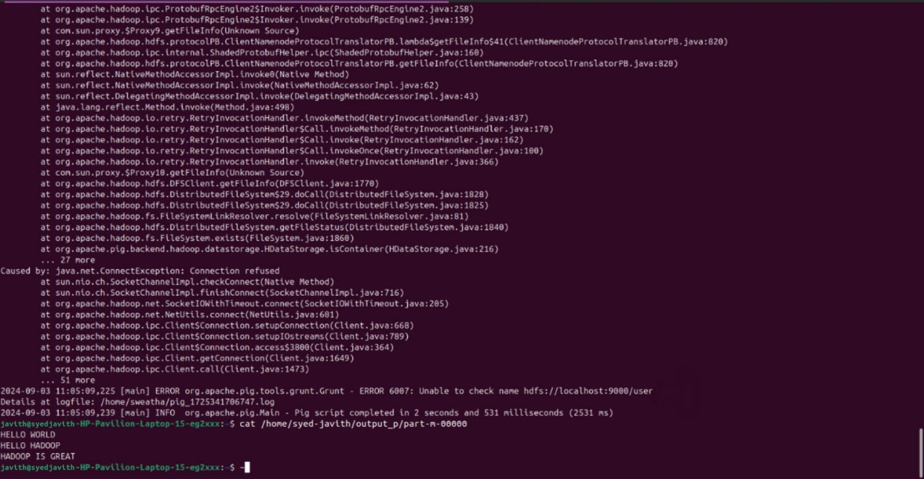

After copy and paste the above output in your local file give the below command to remove the directory from hdfs : hadoop fs -rm -r /weatherdata/output

**Result:**

Thus, the program for weather dataset using Map Reduce has been executed successfully.

**Exp.No.: 4 Create UDF in PIG**

**Step-by-step installation of Apache Pig on Hadoop cluster on Ubuntu Pre-requisite:**

· Ubuntu 16.04 or higher version running (I have installed Ubuntu on Oracle VM (Virtual Machine) VirtualBox),

· Run Hadoop on ubuntu (I have installed Hadoop 3.2.1 on Ubuntu 16.04). You may refer to my blog “How to install Hadoop installation” click [here](https://medium.com/mlearning-ai/installation-of-apache-hadoop-3-2-1-on-ubuntu-67073ce208d7) for Hadoop installation).

**Pig installation steps**

**Step 1:** Login into Ubuntu

**Step 2**: Go to<https://pig.apache.org/releases.html>and copy the path of the latest version of pig that you want to install. Run the following comment to download Apache Pig in Ubuntu:

$ wget <https://dlcdn.apache.org/pig/pig-0.16.0/pig-0.16.0.tar.gz>

**Step 3**: To untar pig-0.16.0.tar.gz file run the following command:

$ tar xvzf pig-0.16.0.tar.gz

**Step 4:** To create a pig folder and move pig-0.16.0 to the pig folder, execute the following command:

$ sudo mv /home/hadoop/pig-0.16.0 /home/hadoop/pig

**Step 5:** Now open the .bashrc file to edit the path and variables/settings for pig. Run the following command:

$ sudo nano .bashrc

Add the below given to .bashrc file at the end and save the file.

#PIG settingsexport PIG_HOME=/home/hdoop/pigexport

PATH=$PATH:$PIG_HOME/binexport

PIG_CLASSPATH=$PIG_HOME/conf:$HADOOP_INSTALL/etc/hadoop/export PIG_CONF_DIR=$PIG_HOME/confexport JAVA_HOME=/usr/lib/jvm/java-8-openjdkamd64export PIG_CLASSPATH=$PIG_CONF_DIR:$PATH#PIG setting ends

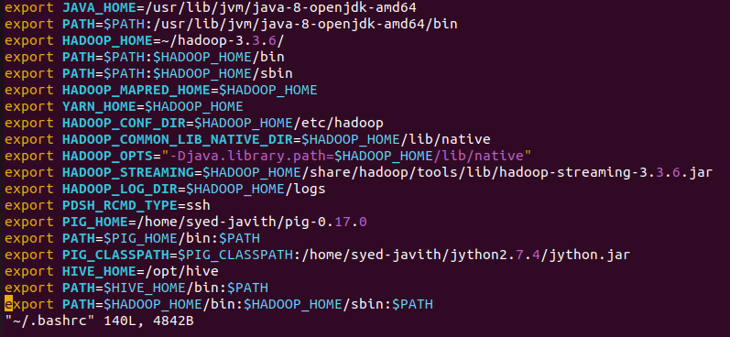

**Step 6:** Run the following command to make the changes effective in the .bashrc file:

$ source .bashrc

**Step 7:** To start all Hadoop daemons, navigate to the hadoop-3.2.1/sbin folder and run the following commands:

$ ./start-dfs.sh$ ./start-yarn$ jps

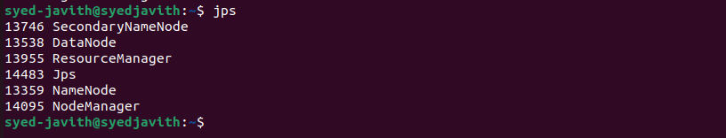

**Step 8:** Now you can launch pig by executing the following command: $ pig

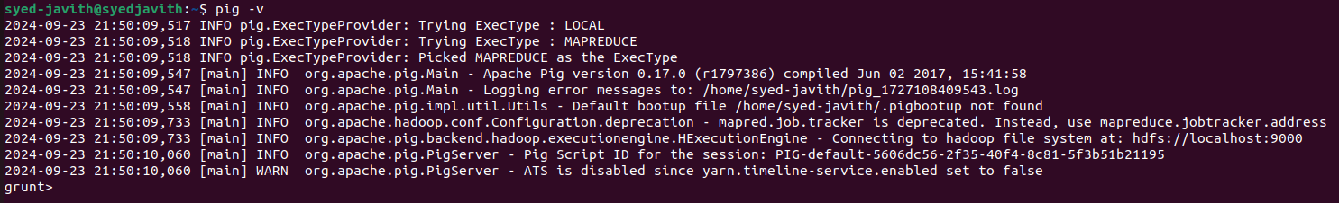

**Step 9:** Now you are in pig and can perform your desired tasks on pig. You can come out of the pig by the quit command:

> quit;

**CREATE USER DEFINED FUNCTION(UDF)**

**Aim** :

To create User Define Function in Apache Pig and execute it on map reduce.

**PROCEDURE:**

**Create a sample text file**

hadoop@Ubuntu:~/Documents$ nano sample.txt

Paste the below content to sample.txt

1,Sri

2,Vaish

3,Subhi

4,Priya

5,Sweatha

hadoop@Ubuntu:~/Documents$ hadoop fs -put sample.txt /home/hadoop/piginput/

**Create PIG File**

hadoop@Ubuntu:~/Documents$ nano demo_pig.pig

**paste the below the content to demo_pig.pig**

-- Load the data from HDFS

data = LOAD '/home/hadoop/piginput/sample.txt' USING PigStorage(',') AS (id:int>

-- Dump the data to check if it was loaded correctly

DUMP data;

--------------------------------------------------------------------------------- **Run the above file**

hadoop@Ubuntu:~/Documents$ pig demo_pig.pig

---------------------------------------------------------------------------------------------------

**Create udf file an save as uppercase_udf.py**

uppercase_udf.py

-------------------------------------------------------------------------------------------- def uppercase(text): return text.upper()

if __name__ == "__main__":

import sys for line in sys.stdin:

line = line.strip() result = uppercase(line) print(result)

-------------------------------------------------------------------------------------------

**Create the udfs folder on hadoop**

**hadoop@Ubuntu:~/Documents$ hadoop fs -mkdir /home/hadoop/udfs**

**put the upppercase_udf.py in to the abv folder**

**hadoop@Ubuntu:~/Documents$ hdfs dfs -put uppercase_udf.py /home/hadoop/udfs/**

**hadoop@Ubuntu:~/Documents$ nano udf_example.pig copy and paste the below content on udf_example.pig**

-- Register the Python UDF script

REGISTER 'hdfs:///home/hadoop/udfs/uppercase_udf.py' USING jython AS udf;

-- Load some data

data = LOAD 'hdfs:///home/hadoop/sample.txt' AS (text:chararray);

-- Use the Python UDF

uppercased_data = FOREACH data GENERATE udf.uppercase(text) AS uppercase_text;

-- Store the result

STORE uppercased_data INTO 'hdfs:///home/hadoop/pig_output_data';

--------------------------------------------------------------------------------------------------------------

**place sample.txt file on hadoop**

hadoop@Ubuntu:~/Documents$ hadoop fs -put sample.txt /home/hadoop/

**To Run the pig file**

hadoop@Ubuntu:~/Documents$ pig -f udf_example.pig

**--------------------------------------------------------------------------------------------------------------**

**To check the output file is created**

hadoop@Ubuntu:~/Documents$ hdfs dfs -ls /home/hadoop/pig_output_data

Found 2 items

If you need to examine the files in the output folder, use:

**To view the output**

**hadoop@Ubuntu:~/Documents$ hdfs dfs -cat /home/hadoop/pig_output_data/part-m00000**



**Result:**

Thus the program to create User Define Function in Apache Pig and execute it on map reduce has been done successfully.

**Exp.No.:5 Installation of Hive on Ubuntu**

**Aim:**

To Download and install Hive, Understanding Startup scripts, Configuration files.

**Procedure:**

**Step 1: Download and extract it**

Download the Apache hive and extract it use tar, the commands given below:

*$wgethttps://downloads.apache.org/hive/hive-3.1.2/apache-hive-3.1.2-bin.tar.gz*

*$ tar –xvf apache-hive-3.1.2-bin.tar.gz*

**Step 2: Place different configuration properties in Apache Hive**

In this step, we are going to do two things o Placing Hive Home path in bashrc file

$*nano .bashrc*

*And append the below lines in it*

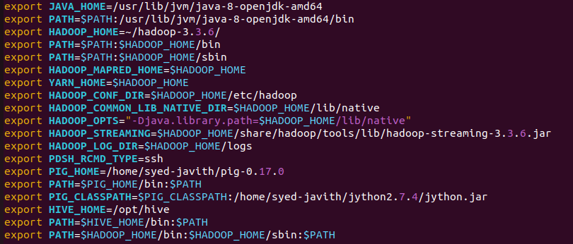

2. Exporting **Hadoop path in Hive-config.sh** (To communicate with the Hadoop eco system we are defining Hadoop Home path in hive config field) **Open the hiveconfig.sh as shown in below** *$cd apache-hive-3.1.2-bin/bin*

*$cp hive-env.sh.template hive-env.sh*

*$nano hive-env.sh*

*Append the below commands on it export HADOOP_HOME=/home/Hadoop/Hadoop*

*export HIVE_CONF_DIR=/home/Hadoop/apache-hive-3.1.2/conf*

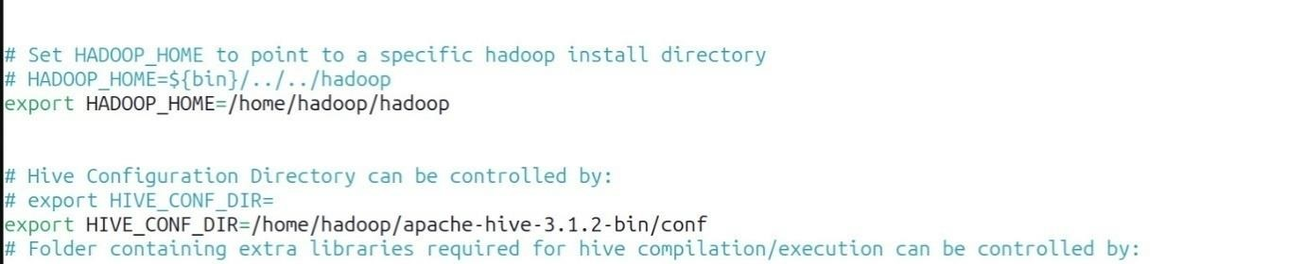

**Step 3: Install mysql**

1. Install mysql in Ubuntu by running this command:

*$sudo apt update*

*$sudo apt install mysql-server*

1. *Alter username and password for MySQLby running below commands:*

*$sudomysql*

Pops command line interface for MySQLand run the below SQL queries to change username and set password

*mysql> SELECT user, host, plugin FROM mysql.user WHERE user = 'root';*

*mysql> ALTER USER 'root'@'localhost' IDENTIFIED WITH 'mysql_native_password' BY*

*'your_new_password';*

*mysql> FLUSH PRIVILEGES;*

**Step 4:Config hive-site.xml**

Config the hive-site.xml by appending this xml code and change the username and password according to your MySQL.

*$cd apache-hive-3.1.2-bin/bin*

*$cp hive-default.xml.template hive-site.xml*

*$nano hive-site.xml*

*Append these lines into it*

*Replace root as your username of MySQL*

*Replaceyour_new_password as with your password of MySQL*

*<configuration>*

*<property>*

*<name>javax.jdo.option.ConnectionURL</name>*

*<value>jdbc:mysql://localhost/metastore?createDatabaseIfNotExist=true</value>*

*</property>*

*<property>*

*<name>javax.jdo.option.ConnectionDriverName</name>*

*<value>com.mysql.cj.jdbc.Driver</value>*

*</property>*

*<property>*

*<name>javax.jdo.option.ConnectionUserName</name>*

*<value>root</value>*

*</property>*

*<property>*

*<name>javax.jdo.option.ConnectionPassword</name>*

*<value>your_new_password</value>*

*</property>*

*<property>*

*<name>datanucleus.autoCreateSchema</name>*

*<value>true</value>*

*</property>*

*<property>*

*<name>datanucleus.fixedDatastore</name>*

*<value>true</value>*

*</property>*

*<property>*

*<name>datanucleus.autoCreateTables</name>*

*<value>True</value>*

*</property>*

*</configuration>*

**Step 5: Setup MySQL java connector:**

*First, you'll need to download the MySQL Connector/J, which is the JDBC driver for*

*MySQL. You can download it from the below link*

[https://drive.google.com/file/d/1QFhB7Kvcat7a4LzDRe6GcmZva1yAxKz/view?usp=drive_link](https://drive.google.com/file/d/1QFhB7Kvcat7a4LzDRe6GcmZva1yAxKz-/view?usp=drive_link)

Copy the downloaded MySQL Connector/J JAR file to the Hive library directory. By default, the Hive library directory is usually located at*/path/to/apache-hive-3.1.2/lib/*on Ubuntu. Use the following command to copy the JAR file:

*$sudo cp /path/to/mysql-connector-java-8.0.15.jar /path/to/apache-hive-3.1.2/lib/ Replace /path/to/ with the actual path to the JAR file.*

**Step 6:Initialize the Hive Metastore Schema:**

*Run the following command to initialize the Hive metastore schema:*

*$$HIVE_HOME/bin/schematool -initSchema -dbTypemysql*

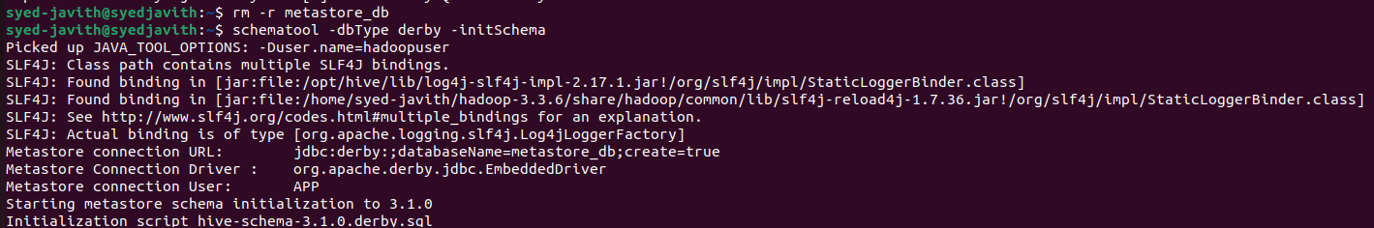

**Step 7: Start hive:**

You can test Hive by running the Hive shell: Copy code hive You should be able to run Hive queries, and metadata will be stored in your MySQL database. *$hive*

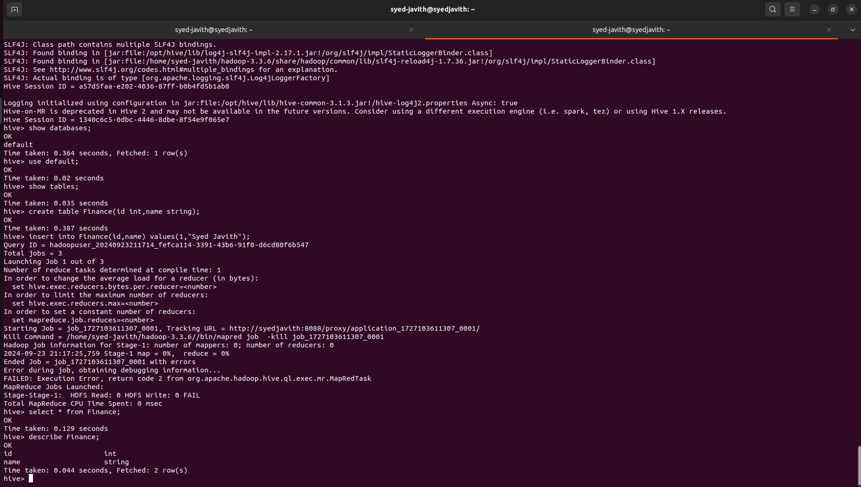

**Result:**

Thus, the Apache Hive installation is completed successfully on Ubuntu.

**Exp.No.: 5a**

**Design and test various schema models to optimize data storage and retrieval** **Using Hive**

**Aim:**

To Design and test various schema models to optimize data storage and retrieval Using Hbase.

**Procedure:**

**Step 1: Start Hive**

Open a terminal and start Hive by running:

$hive

**Step 2: Create a Database**

Create a new database in Hive: hive>CREATE DATABASE financials;

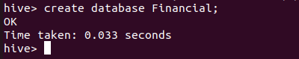

***Step 3: Use the Database****:*

*Switch to the newly created database:* *hive>use financials;*



***Step 4: Create a Table:***

*Create a simple table in your database:*

*hive>CREATE TABLE finance_table( id INT, name STRING );*

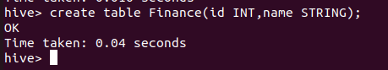

***Step 5: Load Sample Data:***

*You can insert sample data into the table:*

*hive>INSERT INTO finance_tableVALUES (1, 'Alice'), (2, 'Bob'), (3, 'Charlie');*

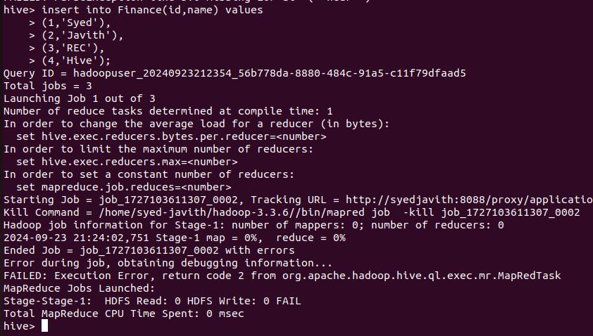

***Step 6: Query Your Data***

*Use SQL-like queries to retrieve data from your table:*

*hive>CREATE VIEW myview AS SELECT name, id FROM finance_table;*



***Step 7: View the data:***

*To see the data in the view, you would need to query the view* *hive>SELECT*FROM myview;*

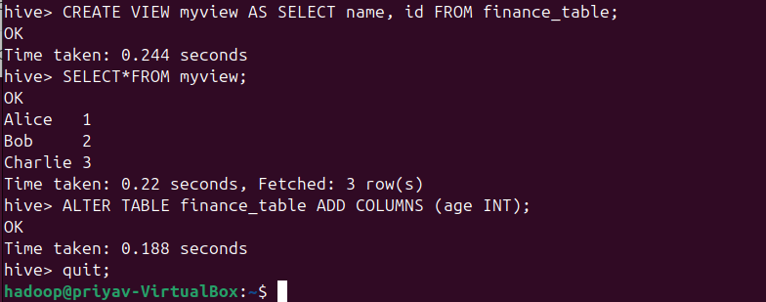

***Step 8: Describe a Table:***

*You can describe the structure of a table using the DESCRIBE command:* *hive>DESCRIBE finance_table;*

***Step 9: Alter a Table:***

*You can alter the table structure by adding a new column:* *hive>ALTER TABLE finance_table ADD COLUMNS (age INT);*



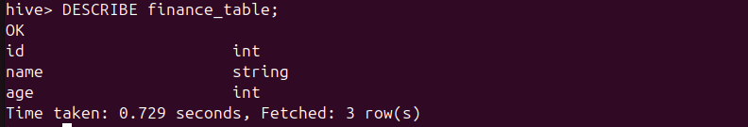

***Step 10: Quit Hive:***

*To exit the Hive CLI, simply type:* *hive>quit;*



**Result:**

Thus, the usage of various commands in Hive has been successfully completed.

**Ex.No.: 6**

**Import a JASON file from the command line. Apply the following actions with the data present in the JASON file where, projection, aggregation, remove, count, limit, skip and sort**

**AIM:**

To import a JASON file from the command line and apply the following actions with the data present in the JASON file where, projection, aggregation, remove, count, limit, skip and sort.

**PROCEDURE:**

**PROCEDURE:**

Step 1: Install Required Packages

Install the necessary packages using pip:

$ pip install pandas --break-system-packages

Step 2: Verify Package Installation

Verify that the required packages are installed:

$ python

>>> import pandas as pd

>>> from hdfs import InsecureClient

>>> print("Pandas version:", pd._version_)

>>> client = InsecureClient('http://localhost:9870', user='hadoop')

>>> print("HDFS status:", client.status('/'))

>>> exit()

Step 3: Create process_data.py File

Create the Python script for processing data:

$ nano process_data.py

Paste the following code into the file:

from hdfs import InsecureClient

import pandas as pd

import json

# Connect to HDFS

hdfs_client = InsecureClient('http://localhost:9870', user='hdfs')

# Read JSON data from HDFS

try:

with hdfs_client.read('/home/hadoop/emp.json', encoding='utf-8') as reader:

json_data = reader.read()

if not json_data.strip():

raise ValueError("The JSON file is empty.")

data = json.loads(json_data)

except Exception as e:

print(f"Error reading or parsing JSON data: {e}")

exit(1)

# Convert JSON data to DataFrame

df = pd.DataFrame(data)

# Projection: Select 'name' and 'salary'

projected_df = df[['name', 'salary']]

# Aggregation: Calculate total salary

total_salary = df['salary'].sum()

# Count: Employees earning more than 50000

high_earners_count = df[df['salary'] > 50000].shape[0]

# Limit: Top 5 highest earners

top_5_earners = df.nlargest(5, 'salary')

# Skip: Skip the first 2 employees

skipped_df = df.iloc[2:]

# Remove: Filter out employees from IT department

filtered_df = df[df['department'] != 'IT']

# Save the filtered data back to HDFS

filtered_json = filtered_df.to_json(orient='records')

try:

with hdfs_client.write('/home/hadoop/filtered_employees.json', encoding='utf-8', overwrite=True) as writer:

writer.write(filtered_json)

except Exception as e:

print(f"Error saving filtered JSON data: {e}")

Step 4: Run the Script

Execute the script to process the data:

$ python3 process_data.py

Step 5: To view the output

hadoop@Ubuntu:~/Documents$ hdfs dfs -cat /home/hadoop/emp.json

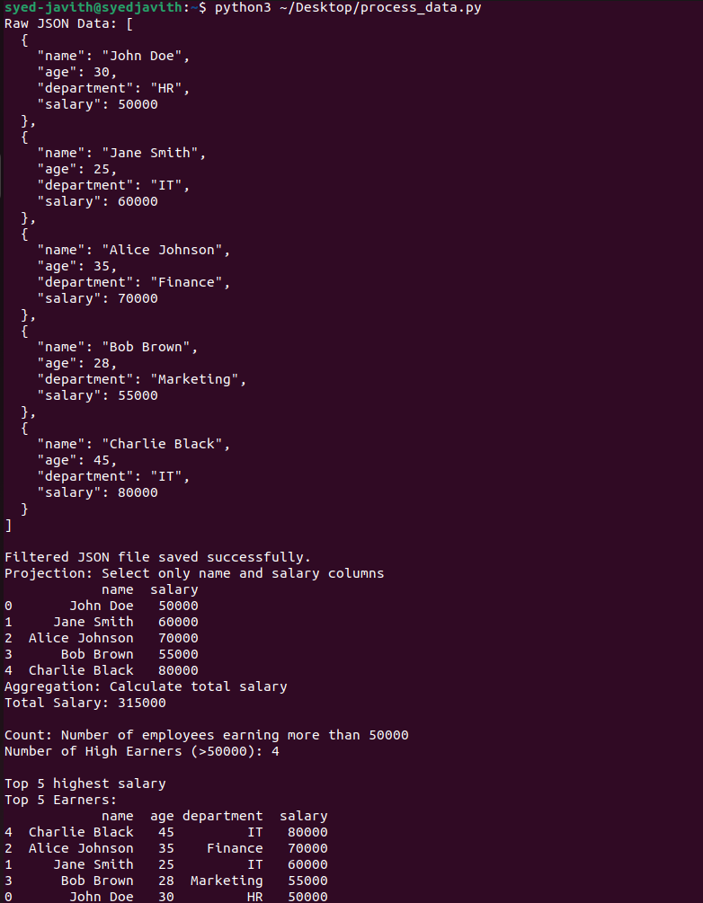

**RESULT:**

Thus to import a JASON file from the command line and apply the following actions with the

data present in the JASON file where, projection, aggregation, remove, count, limit, skip and sort has been executed and verified successfully.

Installation guide for R and RStudio

Step 1 – Install R

1. Download the R installer from https://cran.r--‐project.org/

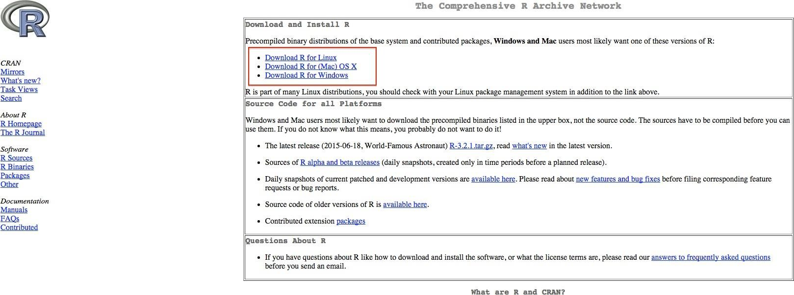

# Figure 1. Screenshot of<http://cran.csiro.au/>

2. Run the installer. Default settings are fine. If you do not have admin rights on your laptop, then ask you local IT support. In that case, it is important that you also ask them to give you full permissions to the R directories. Without this, you will not be able to install additional packages later

Step 2 – Install RStudio

# 1. Download RStudio: https://[www.rstudio.com/products/rstudio/download/](http://www.rstudio.com/products/rstudio/download/)

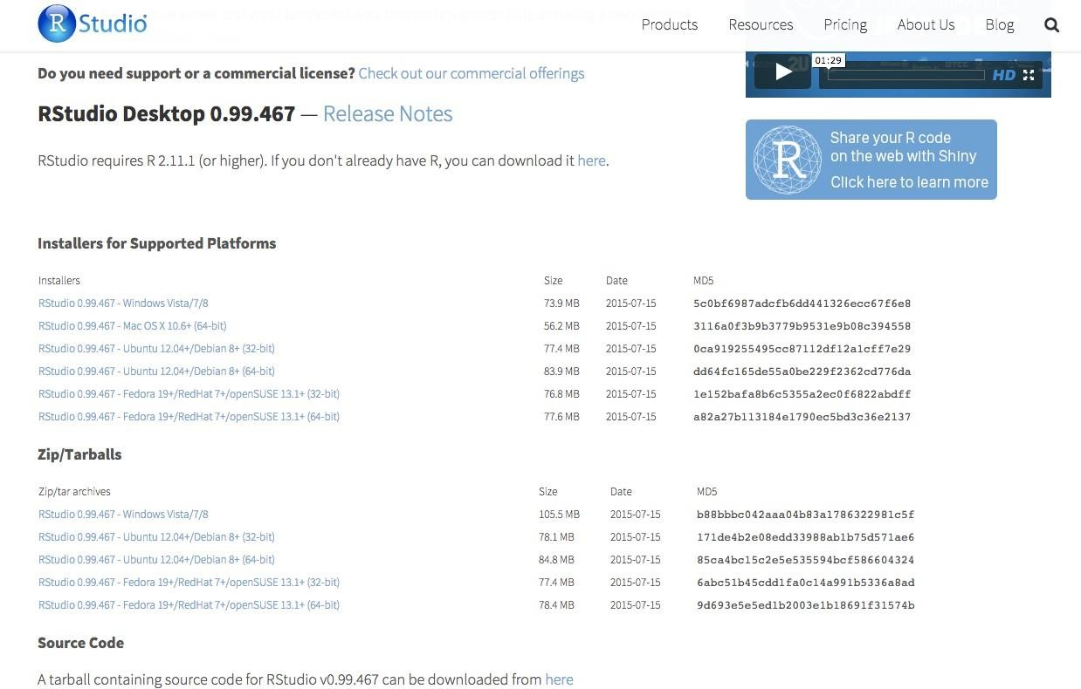

# Figure 2. Download RStudio on https:[//www.rstudio.com/products/rstudio/download/](http://www.rstudio.com/products/rstudio/download/)

* Once the installation of R has completed successfully (and not before), run the RStudio installer.
* If you do not have administrative rights on your laptop, step 2 may fail. Ask your IT Support or download a pre--‐built zip archive of RStudio which doesn’t need installing. The link for this is towards the bottom of the download page, highlighted in Image 2.

* + Download the appropriate archive for your system (Windows/Linux only – the Mac version can be installed into your personal “Applications” folder without admin rights).

* + Double clicking on the zip archive should automatically unpack it on most Windows machines.

Step 3 – Check that R and RStudio are working

* Open RStudio. It should open a window that looks similar to image 3 below.

* In the left hand window, by the ‘>’sign, type ‘4+5’(without the quotes) and hit enter. An output line

reading ‘[1] 9’ should appear. This means that R and RStudio are working.

* If this is not successful, contact us or your local IT support for further advice

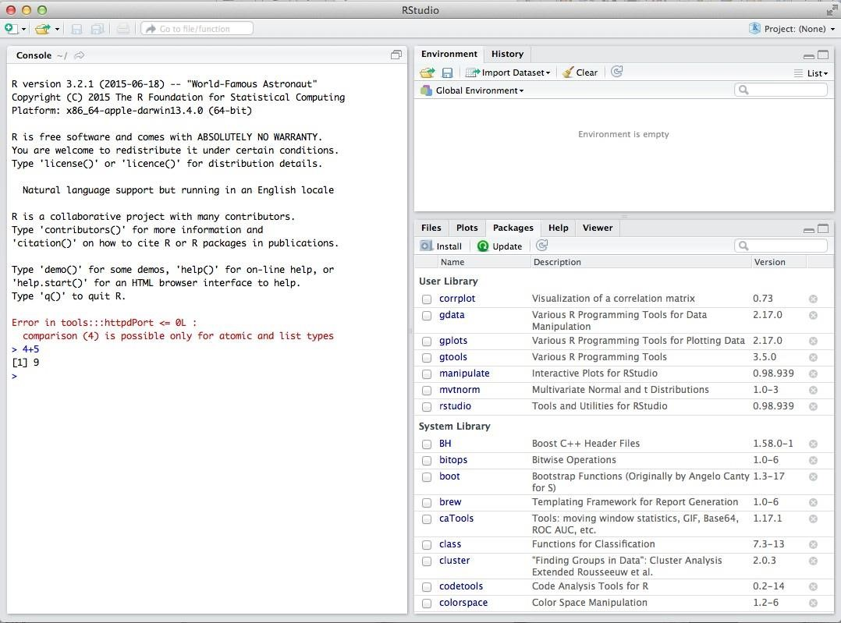

Figure 3. Running R with RStudio

Step 4 – Install R packages required for the workshop

* + Click on the tab ‘ Packages’ then ‘Install’ as shown in Image 4. Or Tools --‐> Install packages.
  + Install the following packages: mixOmics version 6.1.0, mvtnorm, RColorBrewer, corrplot, igraph (see Image 4). For apple mac users, if you are unable to install the mixOmics imported library rgl, you will need to install the XQuartz software first https:[//www.xquartz.org/](http://www.xquartz.org/)
  + Check that the packages are installed by typing ‘library(mixOmics)’ (without the quotes) in the prompt and press enter (see Image 5).
  + Then type ‘sessionInfo()’ and check that mixOmics version 6.1.0 has been installed (image 6).

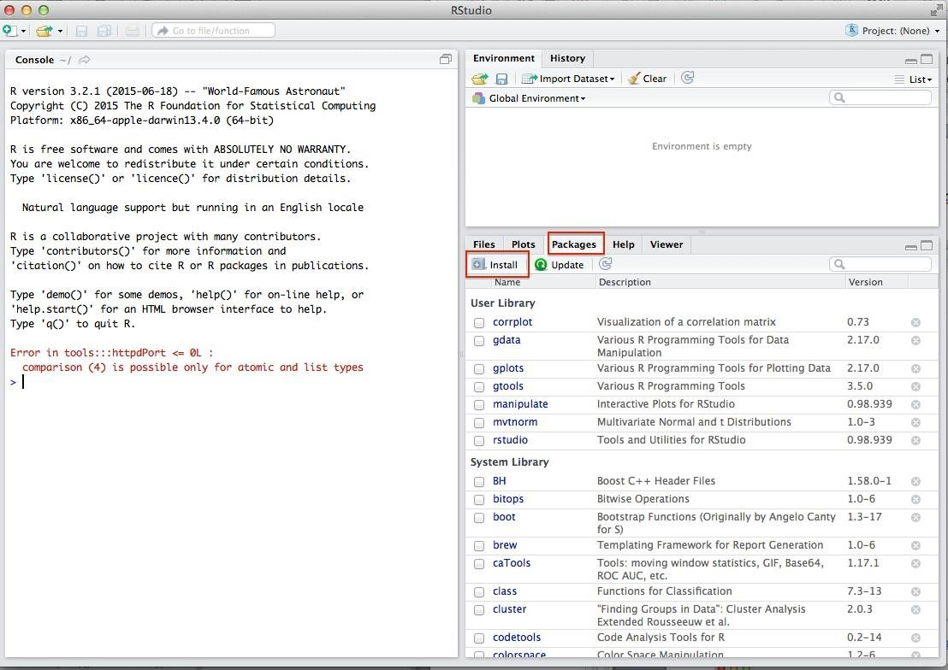

Figure 4. Click on Install to install R packages.

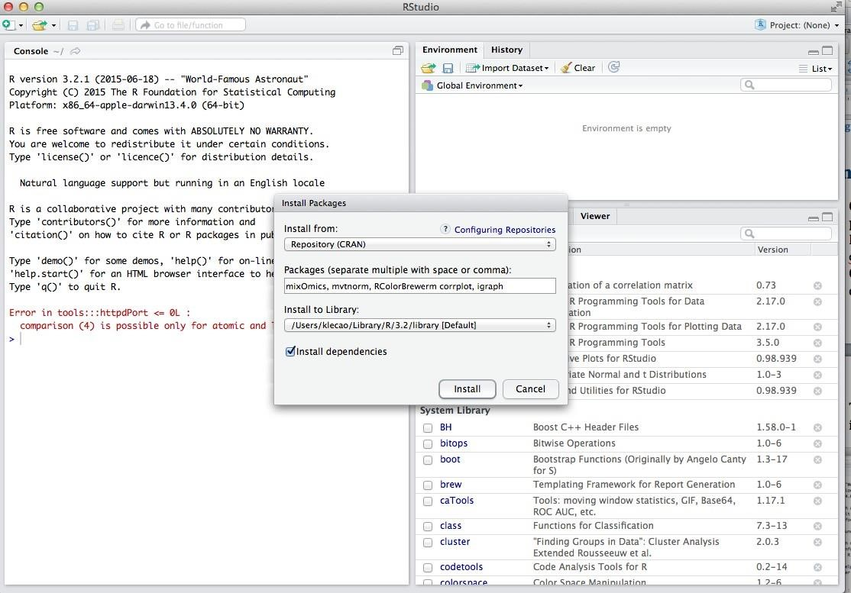

Figure 5. Specify the list of packages to be installed

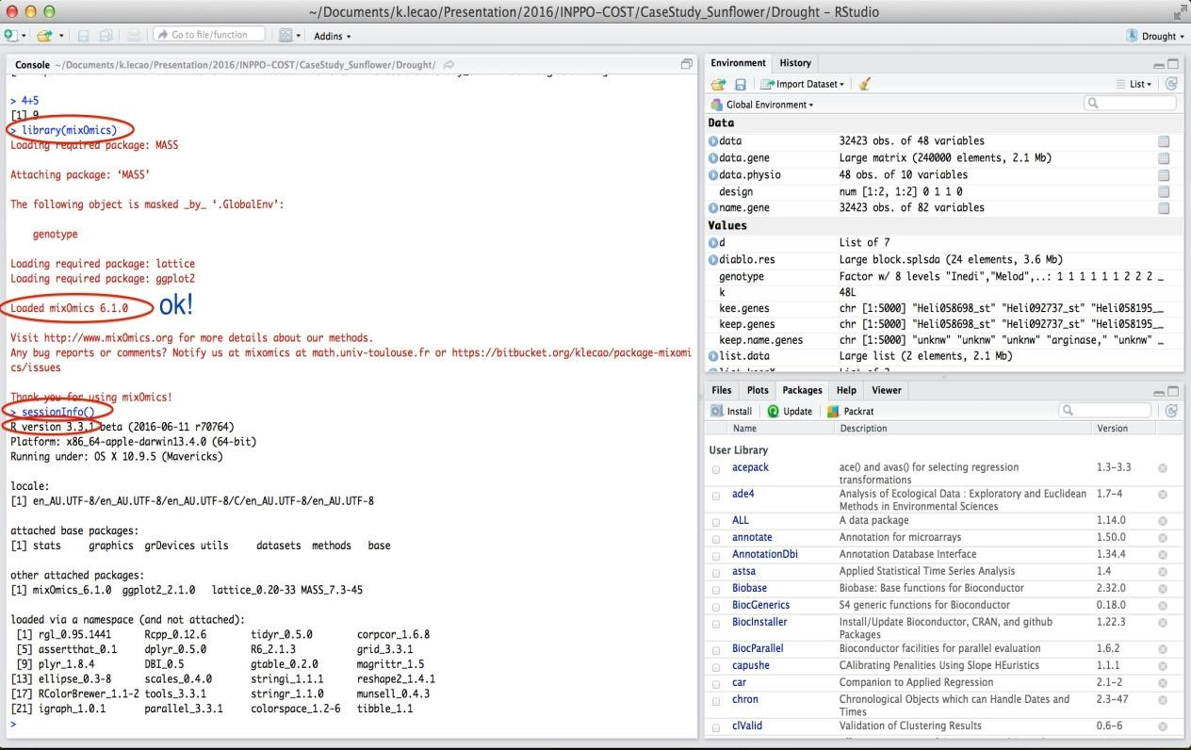

Figure 6. Check that the package mixOmics is installed and has the version 6.1.0.

**Exp.No: 7**

**IMPLEMENT LINEAR AND LOGISTIC REGRESSION**

**AIM:**

To write an R code to implement linear and logistic regression.

**PROCEDURE:**

1. Create sample data for heights and weights, fit a linear regression model, and plot the data with the regression line.
2. Use the sample data to create a data frame for the regression model.
3. Fit the linear regression model using the `lm()` function and display the summary.
4. Plot the data points and add the regression line using the `plot()` and `abline()` functions.
5. Load the `mtcars` dataset, convert the 'am' variable to a factor, fit a logistic regression model using the `glm()` function, and plot the probabilities.

**PROGRAM CODE:**

# a)Linear regression

# Linear Regression

heights <- c(150, 160, 165, 170, 175, 180, 185)

weights <- c(55, 60, 62, 68, 70, 75, 80)

data <- data.frame(heights, weights)

linear_model <- lm(weights ~ heights, data = data)

print(summary(linear_model))

# Plotting Linear Regression

plot(data$heights, data$weights,

main = "Linear Regression: Weight vs. Height",

xlab = "Height (cm)",

ylab = "Weight (kg)",

pch = 19, col = "blue")

abline(linear_model, col = "red", lwd = 2)

**OUTPUT:**

# 

# b) Logistic regression

# Logistic Regression

data(mtcars)

mtcars$am <- factor(mtcars$am, levels = c(0, 1), labels = c("Automatic", "Manual"))

logistic_model <- glm(am ~ mpg, data = mtcars, family = binomial)

print(summary(logistic_model))

# Plotting Logistic Regression

predicted_probs <- predict(logistic_model, type = "response")

print(predicted_probs)

plot(mtcars$mpg, as.numeric(mtcars$am) - 1,

main = "Logistic Regression: Transmission vs. MPG",

xlab = "Miles Per Gallon (mpg)",

ylab = "Probability of Manual Transmission",

pch = 19, col = "blue")

curve(predict(logistic_model, data.frame(mpg = x), type = "response"),

add = TRUE, col = "red", lwd = 2)

**OUTPUT:**

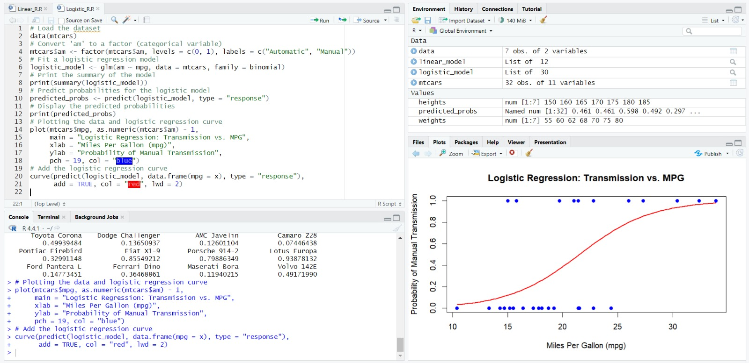

**RESULT:**

Thus the R program to implement Linear and Logistic Regression has been executed and verified successfully.

**Exp.No: 8**

**IMPLEMENT** **SVM/DECISION TREE CLASSIFICATION TECHNIQUES**

**AIM:**

To write an R code to implement SVM/decision tree classification techniques.

**PROCEDURE:**

1. Install and load the required packages (e1071 for SVM and rpart for Decision Tree) and load the iris dataset.
2. Split the dataset into training (70%) and testing (30%) sets using a reproducible random sampling method.
3. Fit the SVM model with a radial kernel using the training data, print the model summary, and evaluate its performance using a confusion matrix and accuracy calculation.
4. Fit the Decision Tree model using the rpart function with the training data, print the model summary, visualize the tree, and evaluate its performance using a confusion matrix and accuracy calculation.
5. Predict the test set results for both SVM and Decision Tree models and assess their accuracy.

## PROGRAM CODE:

## a) SVM IN R

# Install and load the e1071 package (if not already installed)

install.packages("e1071")

library(e1071)

# Load the iris dataset

data(iris)

# Inspect the first few rows of the dataset

head(iris)

# Split the data into training (70%) and testing (30%) sets

set.seed(123) # For reproducibility

sample_indices <- sample(1:nrow(iris), 0.7 * nrow(iris))

train_data <- iris[sample_indices, ]

test_data <- iris[-sample_indices, ]

# Fit the SVM model

svm_model <- svm(Species ~ ., data = train_data, kernel = "radial")

# Print the summary of the model

summary(svm_model)

# Predict the test set

predictions <- predict(svm_model, newdata = test_data)

# Evaluate the model's performance

confusion_matrix <- table(Predicted = predictions, Actual = test_data$Species)

print(confusion_matrix)

# Calculate accuracy

accuracy <- sum(diag(confusion_matrix)) / sum(confusion_matrix)

cat("Accuracy:", accuracy * 100, "%\n")

**OUTPUT:**

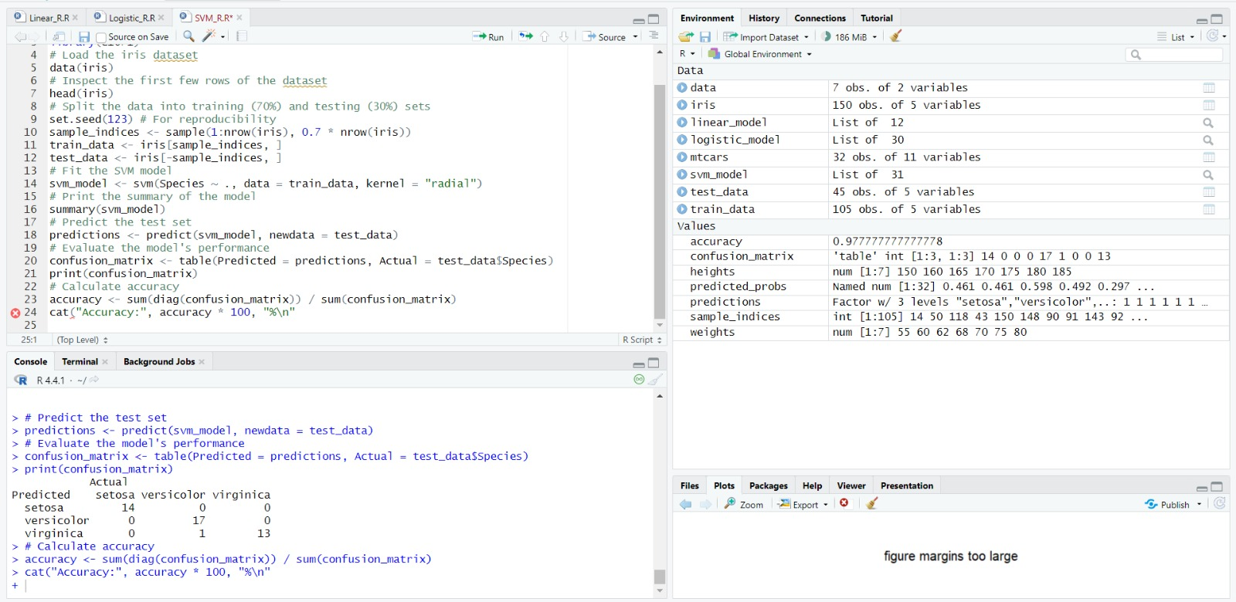

## b) Decision tree in R

# Install and load the rpart package (if not already installed)

install.packages("rpart")

library(rpart)

# Load the iris dataset

data(iris)

# Split the data into training (70%) and testing (30%) sets

set.seed(123) # For reproducibility

sample_indices <- sample(1:nrow(iris), 0.7 * nrow(iris))

train_data <- iris[sample_indices, ]

test_data <- iris[-sample_indices, ]

# Fit the Decision Tree model

tree_model <- rpart(Species ~ ., data = train_data, method = "class")

# Print the summary of the model

summary(tree_model)

# Plot the Decision Tree

plot(tree_model)

text(tree_model, pretty = 0)

# Predict the test set

predictions <- predict(tree_model, newdata = test_data, type = "class")

# Evaluate the model's performance

confusion_matrix <- table(Predicted = predictions, Actual = test_data$Species)

print(confusion_matrix)

# Calculate accuracy

accuracy <- sum(diag(confusion_matrix)) / sum(confusion_matrix)

cat("Accuracy:", accuracy * 100, "%\n")

**OUTPUT:**

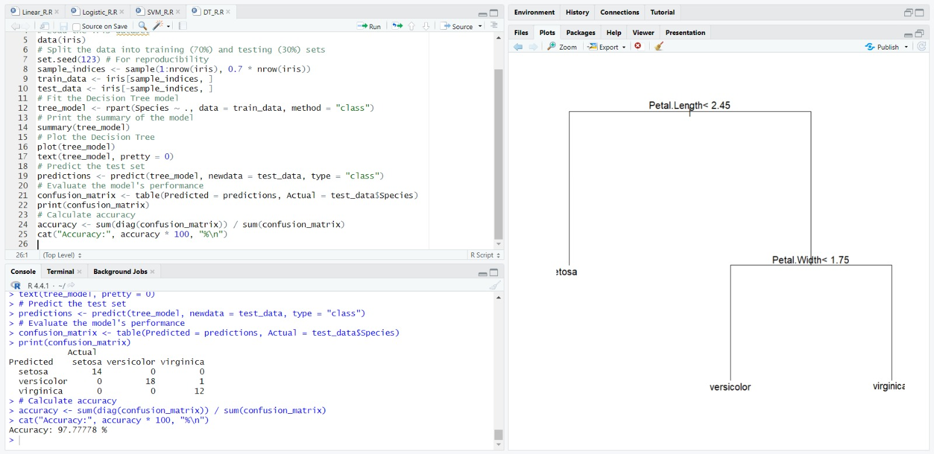

**RESULT:**

Thus the R program to implement SVM/decision tree classification techniques has been executed and verified successfully.

**Exp.No: 9**

**IMPLEMENT CLUSTERING TECHNIQUES – HIERARCHICAL AND KMEANS**

**AIM:**

To write an R code to implement hierarchical and k-means clustering techniques.

**PROCEDURE:**

## Load the iris dataset and use only the numeric columns for clustering by excluding the Species column.

## Standardize the data to ensure all variables have equal weight in the clustering process.

## Compute the distance matrix using the Euclidean method and perform hierarchical clustering using the "complete" linkage method, plot the dendrogram, and cut the tree to form 3 clusters.

## Perform K-means clustering by setting the number of clusters, run the clustering algorithm, and add cluster assignments to the original dataset.

## Display the first few rows of the updated dataset and plot the clusters using ggplot2 for visualization.

**PROGRAM CODE:**

## a) HIERARCHIAL CLUSTERING

# Load the iris dataset data(iris)

# Use only the numeric columns for clustering (exclude the Species column) iris_data <- iris[, -5]

# Standardize the data

iris_scaled <- scale(iris_data)

# Compute the distance matrix distance_matrix <- dist(iris_scaled, method = "euclidean")

# Perform hierarchical clustering using the "complete" linkage method hc_complete <- hclust(distance_matrix, method = "complete")

# Plot the dendrogram plot(hc_complete, main = "Hierarchical Clustering Dendrogram", xlab = "", sub = "", cex =

0.6)

# Cut the tree to form 3 clusters

clusters <- cutree(hc_complete, k = 3)

# Print the cluster memberships print(clusters)

# Add the clusters to the original dataset

iris$Cluster <- as.factor(clusters)

# Display the first few rows of the updated dataset head(iris)

**OUTPUT:**

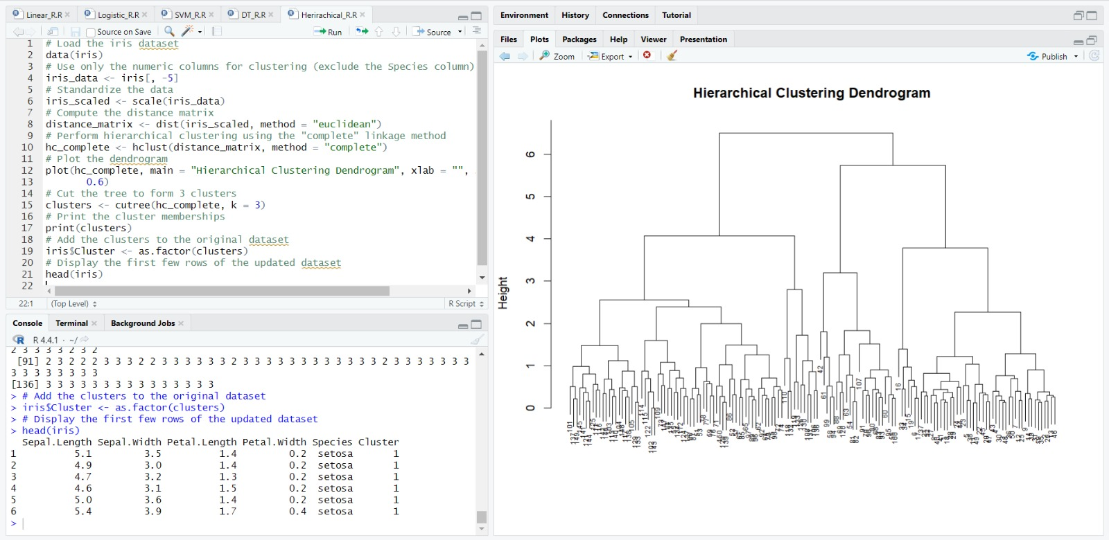

## b) K-MEANS CLUSTERING

# Load the iris dataset data(iris)

# Use only the numeric columns for clustering (exclude the Species column) iris_data <- iris[, -5]

# Standardize the data

iris_scaled <- scale(iris_data)

# Set the number of clusters set.seed(123) # For reproducibility

k <- 3 # Number of clusters

# Perform K-Means clustering

kmeans_result <- kmeans(iris_scaled, centers = k, nstart = 25)

# Print the K-Means result

print(kmeans_result)

# Print the cluster centers

print(kmeans_result$centers)

# Add the cluster assignments to the original dataset iris$Cluster <- as.factor(kmeans_result$cluster)

# Display the first few rows of the updated dataset head(iris)

# Plot the clusters library(ggplot2)

ggplot(iris, aes(x = Sepal.Length, y = Sepal.Width, color = Cluster)) + geom_point(size = 3) +

labs(title = "K-Means Clustering of Iris Dataset", x = "Sepal Length", y = "Sepal Width")

**OUTPUT:**

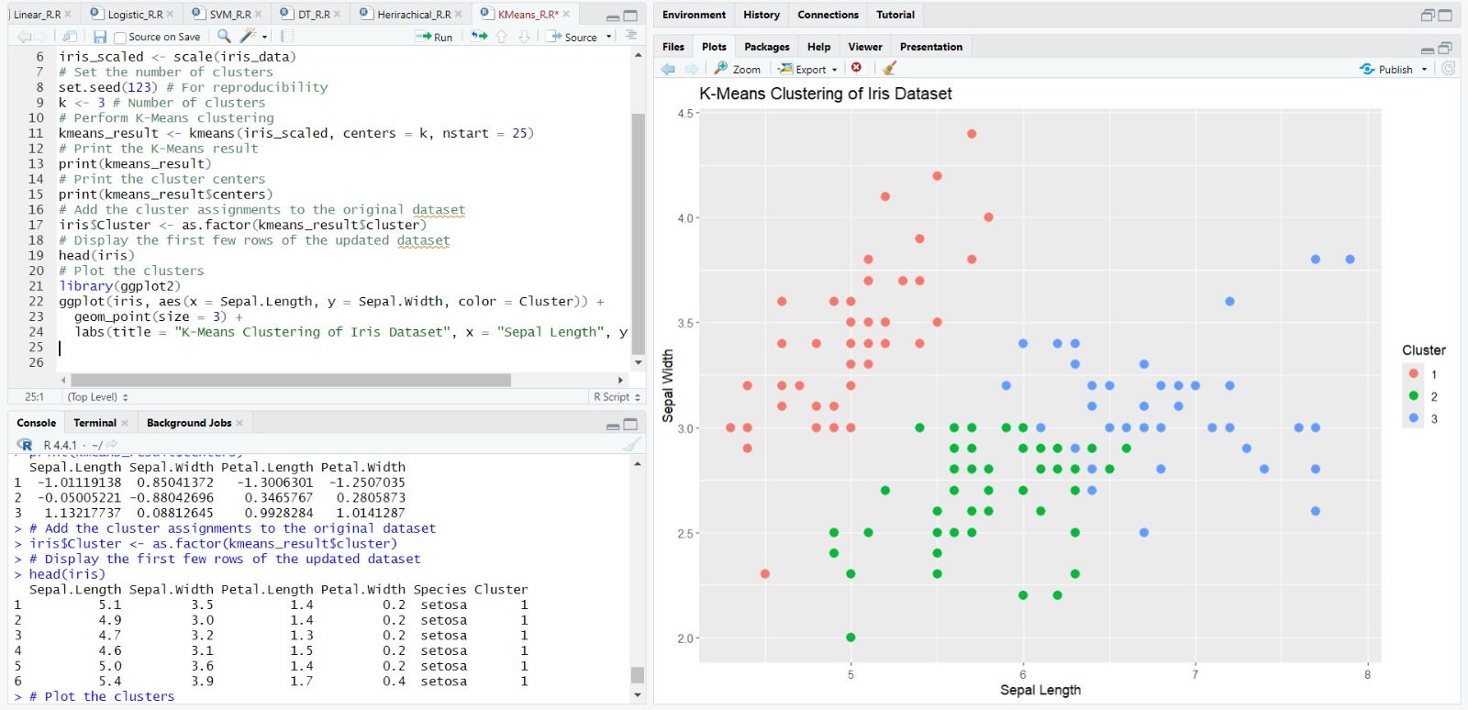

**RESULT:**

Thus the R program to implement hierarchical and k-means clustering techniques has been executed and verified successfully.

**Exp.No:10**

**VISUALIZE DATA USING ANY PLOTTING FRAMEWORK**

**AIM:**

To write an R code to visualize data using plotting framework such as scatter plot, bar char, histogram and box plot.

**PROCEDURE:**

1. Install and Load ggplot2: Ensure the ggplot2 package is installed and loaded to use its plotting functions.
2. Scatter Plot: Create a scatter plot of Sepal Length vs. Sepal Width, colored by Species, to visualize the relationship between these two variables across different species in the iris dataset.
3. Bar Chart: Generate a bar chart to show the count of different Species in the iris dataset, using bars filled with a specified color to represent the counts.
4. Histogram: Create a histogram of Sepal Length to visualize the frequency distribution of this variable within the dataset, specifying the bin width and colors for the histogram bars.
5. Box Plot: Plot a box plot of Sepal Length for each Species to compare the distribution and central tendency of Sepal Length across the different species in the dataset.

## 1) SCATTER PLOT

# Install ggplot2 (if not already installed)

install.packages("ggplot2")

# Load the ggplot2 package

library(ggplot2)

# Scatter plot of Sepal.Length vs Sepal.Width, colored by Species

ggplot(data = iris, aes(x = Sepal.Length, y = Sepal.Width, color = Species)) +

geom_point(size = 3) + # Adds points

labs(title = "Scatter Plot of Sepal Dimensions",

x = "Sepal Length (cm)",

y = "Sepal Width (cm)") + # Adds axis labels and title

theme_minimal() # Applies a minimal theme

**OUTPUT:**

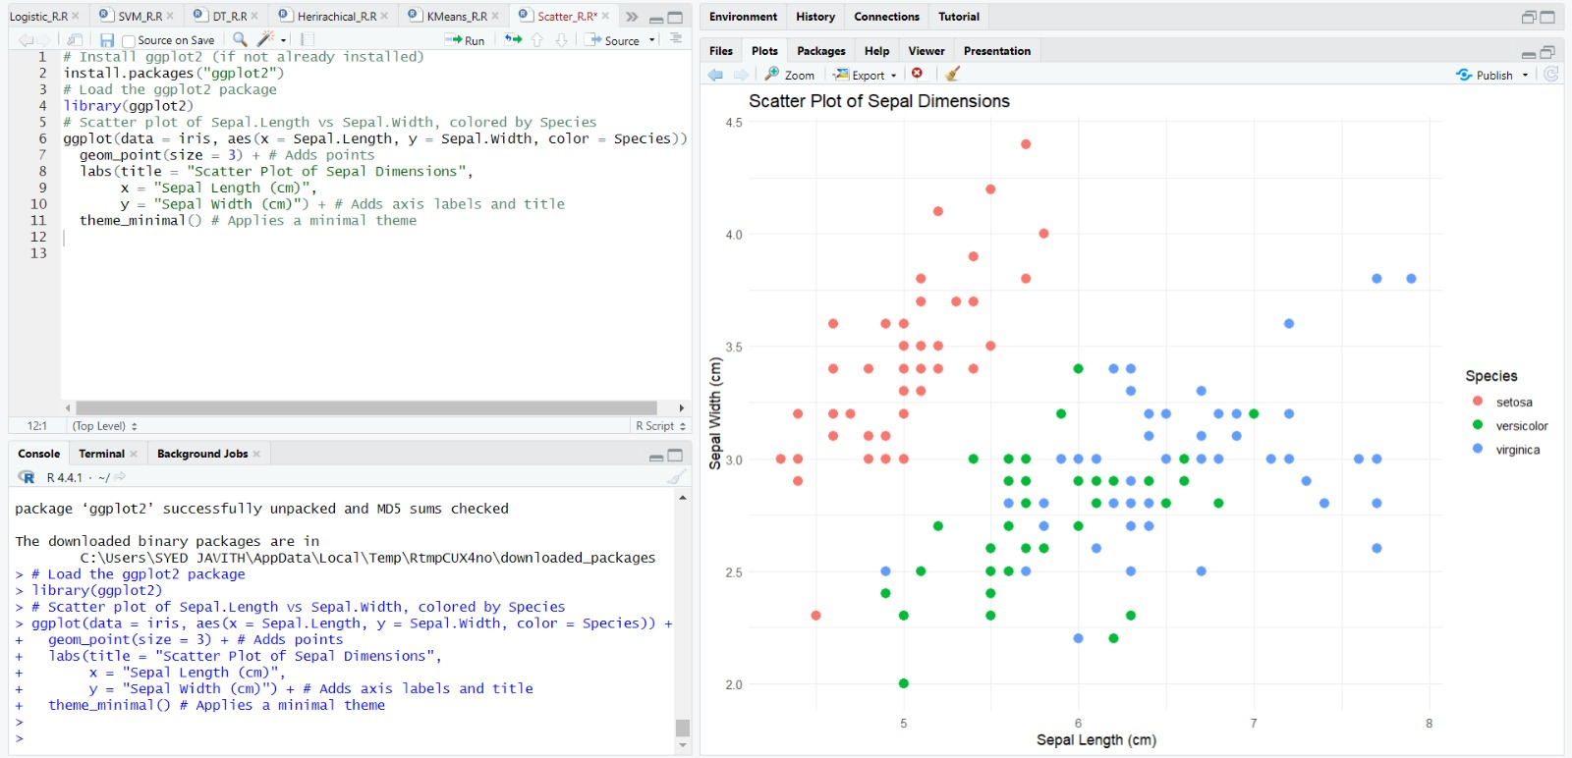

## 2) BAR CHART

# Install ggplot2 (if not already installed)

install.packages("ggplot2")

# Load the ggplot2 package

library(ggplot2)

# Bar plot of Species counts

ggplot(data = iris, aes(x = Species)) +

geom_bar(fill = "steelblue") + # Adds bars filled with steel blue color

labs(title = "Count of Different Species in Iris Dataset",

x = "Species",

y = "Count") +

theme_minimal()

**OUTPUT:**

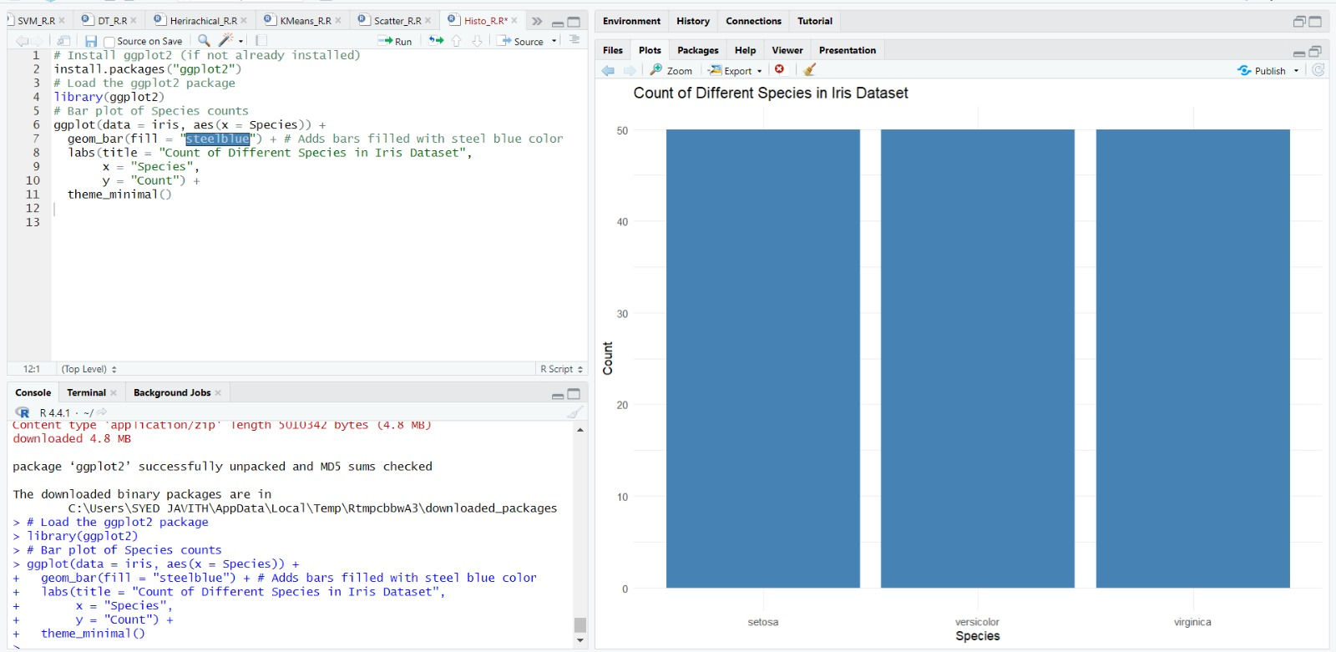

**3) HISTOGRAM**

# Histogram of Sepal Length

ggplot(data = iris, aes(x = Sepal.Length)) +

geom_histogram(binwidth = 0.3, fill = "orange", color = "black") + # Adds histogram bars

labs(title = "Histogram of Sepal Length",

x = "Sepal Length (cm)",

y = "Frequency") +

theme_minimal()

**OUTPUT:**

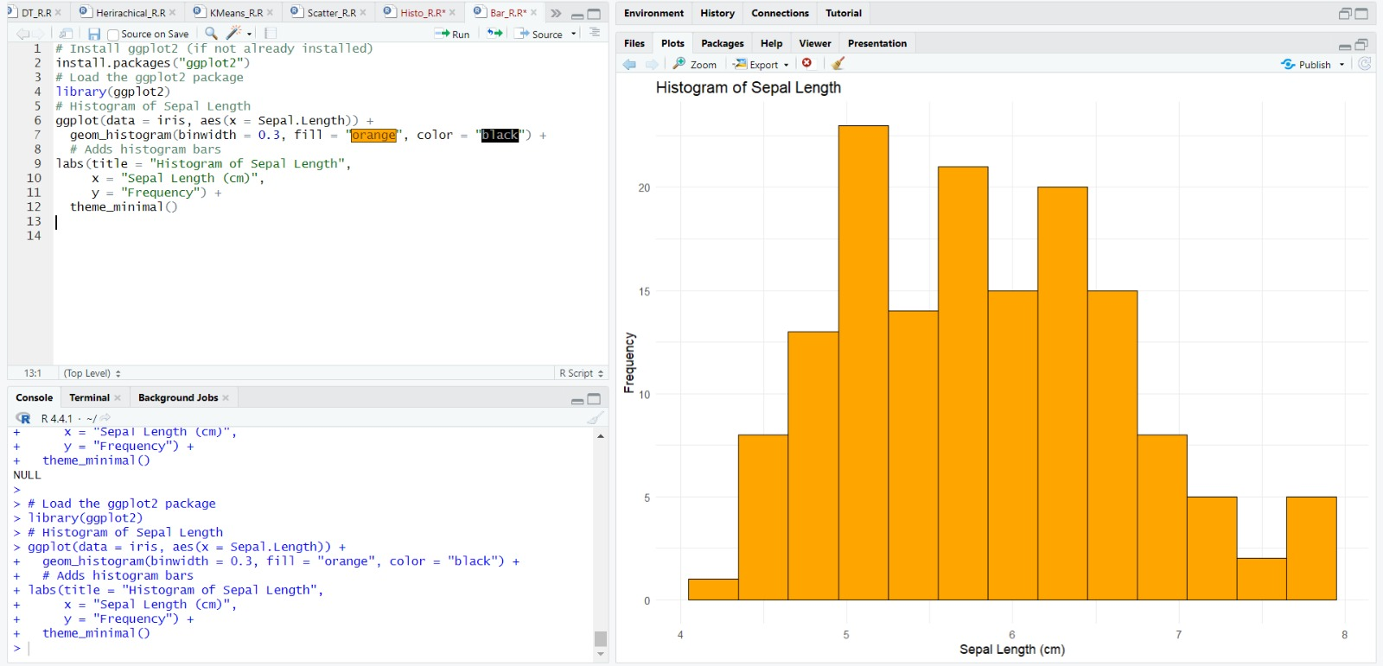

**4)BOX PLOT**

# Box plot of Sepal Length for each Species

ggplot(data = iris, aes(x = Species, y = Sepal.Length, fill = Species)) +

geom_boxplot() + # Adds box plot

labs(title = "Box Plot of Sepal Length by Species",

x = "Species",

y = "Sepal Length (cm)") +

theme_minimal()

**OUTPUT:**

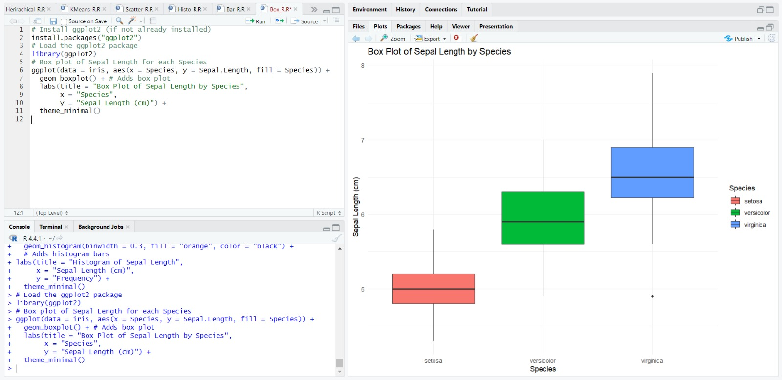

**RESULT:**

Thus the R program to visualize data using plotting framework such as scatter plot, bar char, histogram and box plot has been executed and verified successfully.